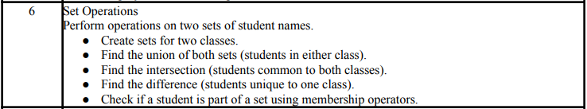
COMMAND:
'''Set Operations
Perform operations on two sets of student names.
● Create sets for two classes.
● Find the union of both sets (students in either class).
● Find the intersection (students common to both classes).
● Find the difference (students unique to one class).
● Check if a student is part of a set using membership operators.'''

# Take input for Class A students
class_A = set(input("Enter names for Class A students (separated by spaces): ").split())

# Take input for Class B students
class_B = set(input("Enter names for Class B students (separated by spaces): ").split())

print("\nClass A Students:", class_A)
print("Class B Students:", class_B)

# Union - students in either class
union_students = class_A | class_B
print("\nUnion (Either Class):", union_students)

# Intersection - students common to both classes
common_students = class_A & class_B
print("Intersection (Common Students):", common_students)

# Difference - students unique to Class A
unique_A = class_A - class_B
print("Difference (Only in Class A):", unique_A)

# Difference - students unique to Class B
unique_B = class_B - class_A
print("Difference (Only in Class B):", unique_B)

# Membership check
student_name = input("\nEnter a name to check in Class A: ")
if student_name in class_A:
print(f"{student_name} is in Class A")
else:
print(f"{student_name} is NOT in Class A")

student_name = input("Enter a name to check in Class B: ")
if student_name in class_B:
print(f"{student_name} is in Class B")
else:
print(f"{student_name} is NOT in Class B")

OUTPUT:
